https://www.jdoodle.com/embed/v0/5RZ9

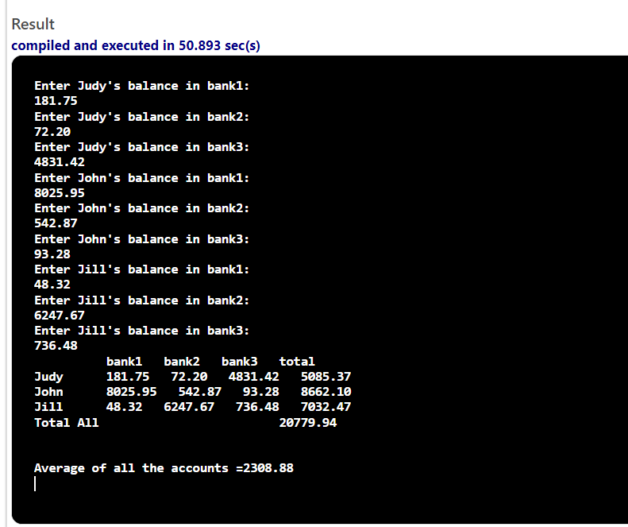

#include <iostream>
#include <iomanip>
using namespace std;
int main()
{
double
bal11, bal12, bal13, bal21, bal22, bal23,bal31, bal32, bal33, total1, total2, total3, totalAll,avg;
cout<<"Enter Judy's balance in bank1: "<<endl;
cin>> bal11;
cout<<"Enter Judy's balance in bank2: "<<endl;
cin>>bal12;
cout<<"Enter Judy's balance in bank3: "<<endl;
cin>>bal13;
cout<<"Enter John's balance in bank1: "<<endl;
cin>>bal21;
cout<<"Enter John's balance in bank2: "<<endl;
cin>>bal22;
cout<<"Enter John's balance in bank3: "<<endl;
cin>>bal23;
cout<<"Enter Jill's balance in bank1: "<<endl;
cin>>bal31;
cout<<"Enter Jill's balance in bank2: "<<endl;
cin>>bal32;
cout<<"Enter Jill's balance in bank3: "<<endl;
cin>>bal33;
total1=bal11+bal12+bal13;
total2=bal21+bal22+bal23;
total3=bal31+bal32+bal33;
totalAll=total1+total2+total3;
avg=totalAll/9;
cout<<" "<<"bank1"<<" "<<"bank2"<<" "<<"bank3"<<" "<<"total"<<endl;
cout<<"Judy"<<" "<<bal11<<fixed<<setprecision(2)<<" "<<bal12<<fixed<<setprecision(2)<<" "<<bal13<<fixed<<setprecision(2)<<" "<<total1<<fixed<<setprecision(2)<<endl;
cout<<"John"<<" "<<bal21<<fixed<<setprecision(2)<<" "<<bal22<<fixed<<setprecision(2)<<" "<<bal23<<fixed<<setprecision(2)<<" "<<total2<<fixed<<setprecision(2)<<endl;
cout<<"Jill"<<" "<<bal31<<fixed<<setprecision(2)<<" "<<bal32<<fixed<<setprecision(2)<<" "<<bal33<<fixed<<setprecision(2)<<" "<<total3<<fixed<<setprecision(2)<<endl;
cout<<"Total All"<<" "<<totalAll<<fixed<<setprecision(2)<<endl;
cout<<endl;
cout<<endl;
cout<<"Average of all the accounts ="<<avg<<fixed<<setprecision(4)<<endl;

return 0;
}

